Name: ______________________
(ESL)

Declaration of Independence
Cloze Sentences Practice

Use the words from the word bank below to complete this excerpt of the Declaration of Independence.

Truths | Laws of Nature | Rights
Liberty | Powers | Political
Causes | Consent of the Governed | Safety
Governments | Destructive | Equal
Abolish | Human Events

When in the Course of ___________ ______________ it becomes necessary for one people to dissolve the ______________ bands which have connected them with another and to assume among the powers of the earth, the Separate and Equal station to which the ________ ____ ___________ and of Nature's God entitle them, a decent respect to the opinions of mankind requires that they should declare the __________ which impel them to the separation.
We hold these ____________ to be self-evident, that all men are created _________, that they are endowed by their Creator with certain unalienable __________, that among these are Life, _____________ and the pursuit of Happiness. — That to secure these rights, ______________ are instituted among Men, deriving their just ___________ from the ___________ ___ ____ _________________, — That whenever any Form of Government becomes _________________ of these ends, it is the Right of the People to alter or to _____________ it, and to institute new Government, laying its foundation on such principles and organizing its powers in such form, as to them shall seem most likely to effect their __________ and Happiness.

Name: _______________________________

Summarizing the Declaration of Independence

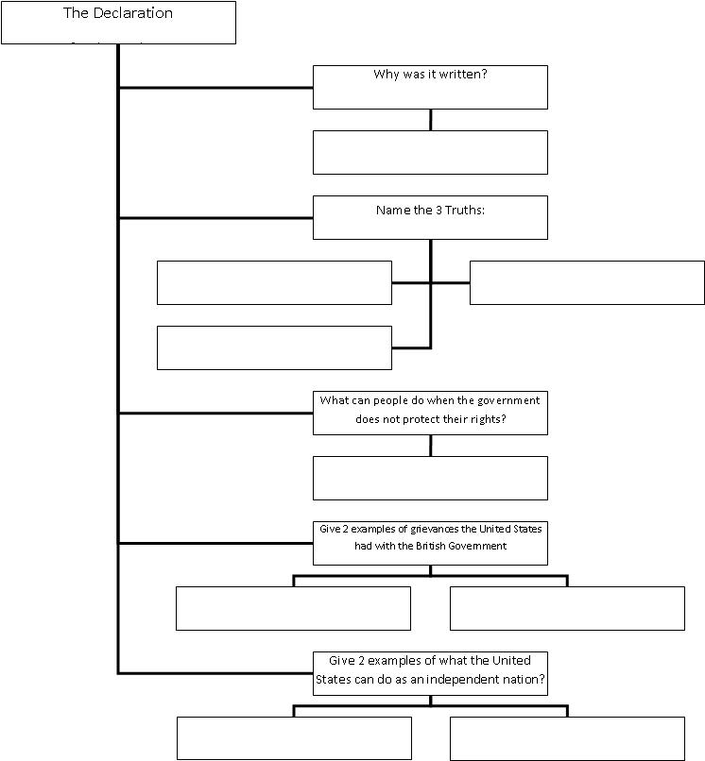

Name: _______________________
A Revolutionary Idea…
Fill in the following key vocabulary next to each arrow: Social Contract, Natural Rights, Limited Government, Popular Sovereignty. Some terms you will use more than once.
Declaration of Independence | In modern words… | Key Vocabulary
“When in the course of human events, it becomes necessary for one people to dissolve the political bands which have connected them with another...” | Whenever a group of people needs to split from their government...
“...and to assume among the powers of the earth, the separate and equal station to which the laws of nature and of nature’s God entitle them...” | ...and assert their God given independence and equality...
“...a decent respect to the opinions of mankind requires that they should declare the causes which impel them to the separation.” | It’s always important to list the reasons why.
“...We hold these truths to be self-evident...” | We think everyone knows…
“...that all men are created equal, that they are endowed by their creator with certain unalienable rights...” | ...that God created every person equal, and gave each person specific unchanging rights which should never be taken away.
“...that among these are Life, Liberty, and the pursuit of happiness...” | These include the right of the people to live life in freedom and pursue their dreams and goals.
“–That to secure these rights, Governments are instituted among men, deriving their just powers from the consent of the governed...” | The very reason we have man-made governments is to protect these rights, not to interfere with them. Whatever power and authority governments have are given by the people’s permission and limited to their protection.

“...that whenever any form of government becomes destructive of these ends, it is the right of the people to alter or to abolish it...” | When any government stops protecting the life, freedoms, and happiness of the people, then they have the right to change the government or even to get rid of the government
“...and to institute new government, laying its foundation on such principles, and organizing its powers in such form, as to them shall seem most likely to effect their safety and happiness.” | The people have the right to set up a new, better government organized to keep the people safe and happy.
“Prudence, indeed, will dictate that governments long established should not be changed for light and transient causes;” | Governments should not be changed for a silly reason.
“and accordingly all experience hath shown, that mankind are more disposed to suffer, while evils are sufferable, than to right themselves by abolishing the forms to which they are accustomed.” | And, in fact, history shows that people are more likely to put up with an unbearable government than they are to fight to correct the problem.
“But when a long train of abuses and usurpations, pursuing invariably the same object, evinces a design to reduce them under absolute despotism, it is their Right, it is their Duty, to throw off such government, and to provide new guards for their future security.” | But when a government becomes too abusive with consistent, repeated violations of the people’s rights, then the people have the right – in fact, the duty – to revolt against the government, and put new rules in place to protect their future rights.

Name: _______________________
A Revolutionary Idea…
Enrichment
Declaration of Independence |  | In modern words… | Key Vocabulary
“When in the course of human events, it becomes necessary for one people to dissolve the political bands which have connected them with another...” |  |  | Social Contract
“...and to assume among the powers of the earth, the separate and equal station to which the laws of nature and of nature’s God entitle them...” |  | ...and assert their God given independence and equality... | Natural Rights
“...a decent respect to the opinions of mankind requires that they should declare the causes which impel them to the separation.” |  | It’s always important to list the reasons why.
“...We hold these truths to be self-evident...”

“...that all men are created equal, that they are endowed by their creator with certain unalienable rights...” |  |  | Natural Rights
“...that among these are Life, Liberty, and the pursuit of happiness...”

“–That to secure these rights, Governments are instituted among men, deriving their just powers from the consent of the governed...” |  | The very reason we have man-made governments is to protect these rights, not to interfere with them. Furthermore, whatever power and authority governments have are given by the people’s permission and limited to their protection. | Social Contract
Declaration of Independence | In modern words… |  |  | Key Vocabulary
“...that whenever any form of government becomes destructive of these ends, it is the right of the people to alter or to abolish it...” | When any government starts to undermine the very purpose of protecting the life, freedoms, and happiness of the people, then they have the right to change the government or, yes, even to get rid of the government |  |  | Limited Government
“...and to institute new government, laying its foundation on such principles, and organizing its powers in such form, as to them shall seem most likely to effect their safety and happiness.” |  |  |  | Popular Sovereignty
“Prudence, indeed, will dictate that governments long established should not be changed for light and transient causes;”

“and accordingly all experience hath shown, that mankind are more disposed to suffer, while evils are sufferable, than to right themselves by abolishing the forms to which they are accustomed.” | And, in fact, history shows that people are more likely to put up with an unbearable government, than they are to fight to correct the problem.
“But when a long train of abuses and usurpations, pursuing invariably the same object, evinces a design to reduce them under absolute despotism, it is their Right, it is their Duty, to throw off such government, and to provide new guards for their future security.” |  |  |  | Social Contract

